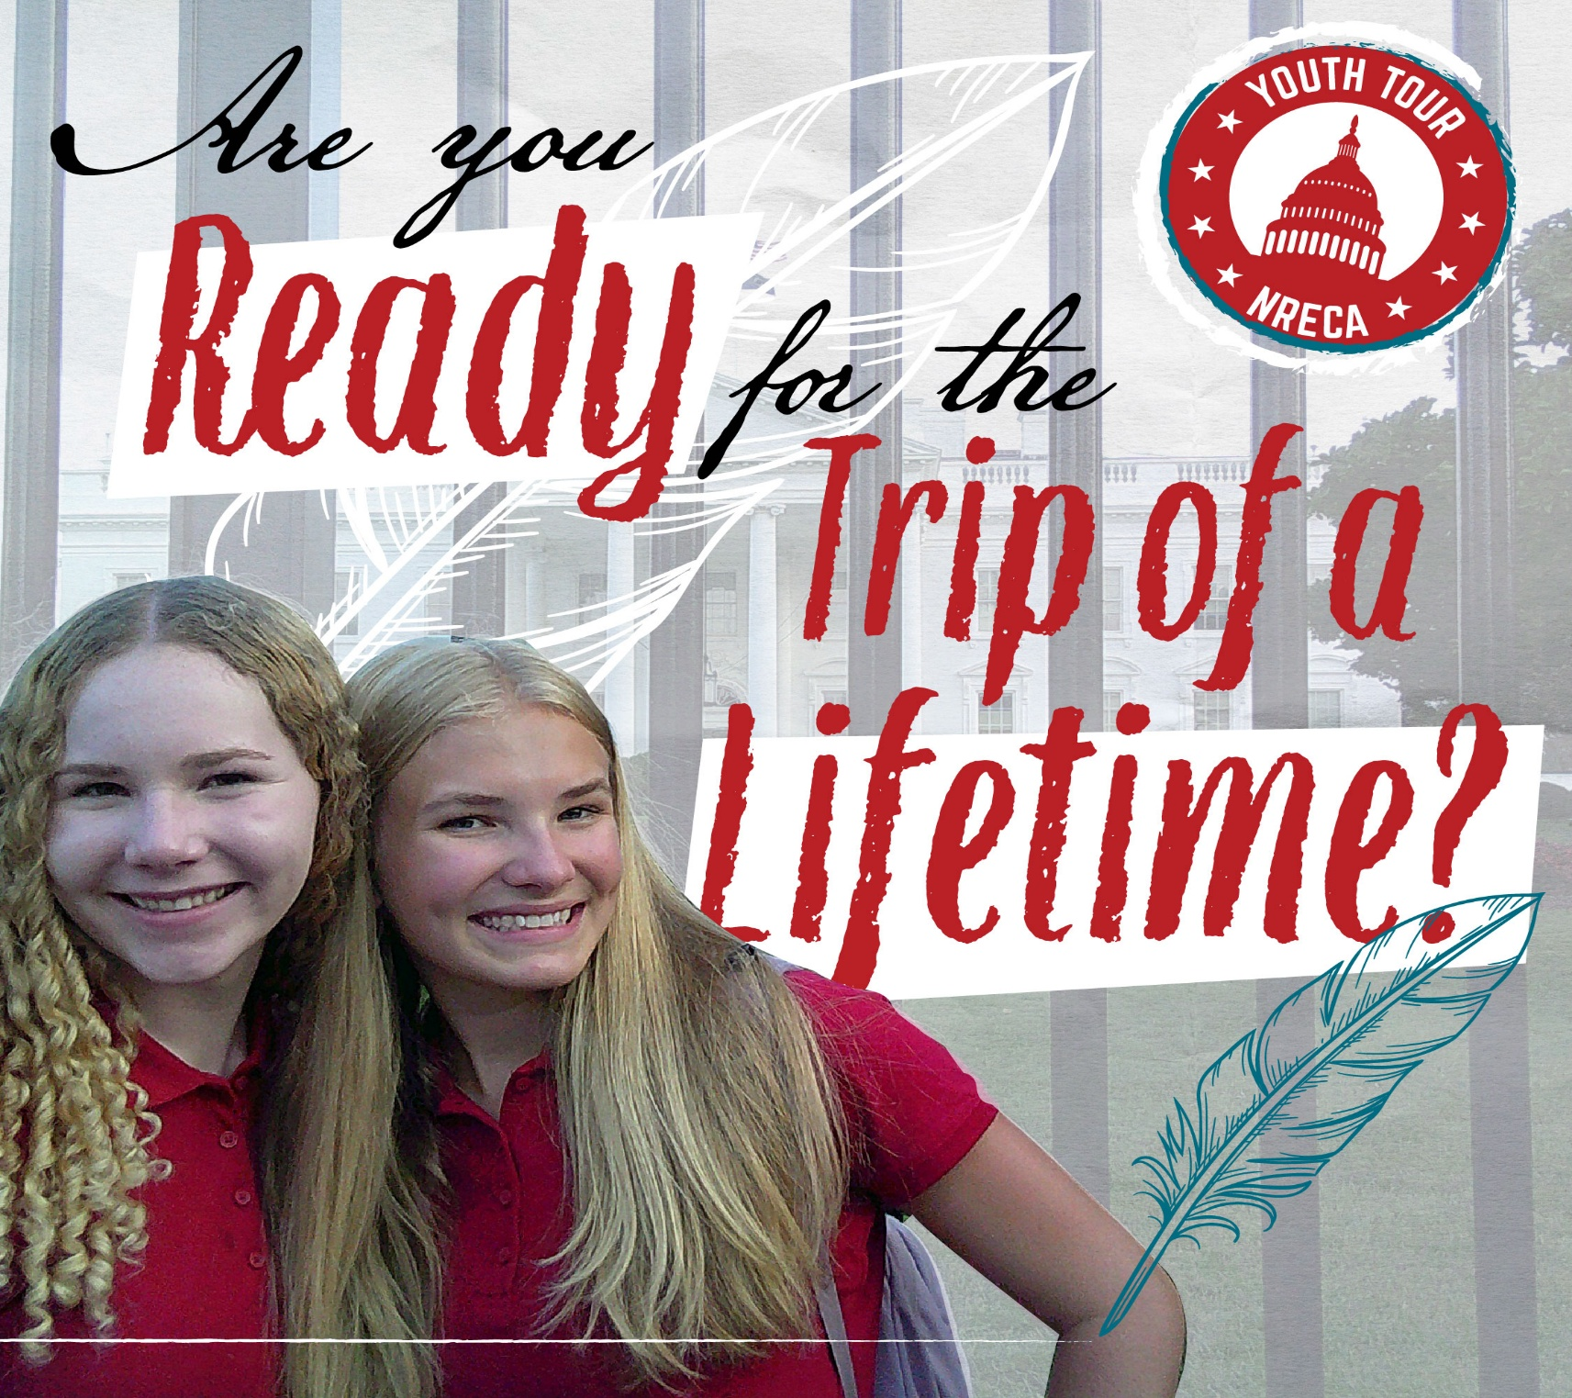 2026 Washington DC Youth Tour
June 15-20, 2026
Each entrant must submit an essay, not to exceed 500 words, on the following topic: “If chosen as a youth tour delegate, you will be traveling to Washington, D.C. to experience and learn about America’s rich history. What moment in American history do you wish you had been a part of, and what would you have contributed?”
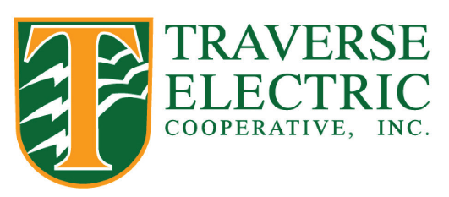
All essays must be typed and include a cover sheet that states the title of the essay, the entrant’s name and address, name of parent or guardian, and the name of your school. Applicants should be a dependent of a Traverse Electric member and a high school junior or senior or at least age 16. Essay deadline is February 9, 2026.
Essays should be sent to Traverse Electric, PO Box 66, Wheaton, MN 56296 or emailed to klupkes@traverseelectric.com.
This all-expense paid trip is sponsored by your local member-owned rural electric cooperative.

